

**A**

**PROJECT REPORT ON**

# “ CAR SERVICING MANaGEMEnT SYSTEM ”

**SUBMITTED TO**

**Vivekanand College Kolhapur (Autonomous)**

**SHIVAJI UNIVERSITY, KOLHAPUR.**

**FOR THE AWARD OF**

**“ B.Sc. COMPUTER SCIENCE ENTIRE ”**

**By**

**Mr. SAHIL SUBHASH SAWANT**

**(Roll No: 9254)**

**Mr. ONKAR YASWANT PATIL**

**(Roll No: 9239)**

**UNDER THE GUIDENCE OF**

## Mr. Rajesh Mane

**(DEPARTMENT OF B.Sc. COMPUTER SCIENCE ENTIRE)**

**THROUGH**

**Vivekanand College Kolhapur (Autonomous)**

**2020-2021**



**Vivekanand College Kolhapur (Autonomous)**

# Guide’s Certificate

**This is to certify that SAHIL SUBHASH SAWANT and ONKAR YASHWANT PATIL under the guidance of RAJESH R. MANE satisfactory completed the project work on “CAR SERVICING MANAGEMENT SYSTEM ” for the practical fulfilment of B.Sc. Computer Science Entire SHIVAJI UNIVERSITY, KOLHAPUR during the academic year 2020-2021. To best knowledge & belief the matter presented by them are original & not copied for any source. Also this report has not been submitted earlier for the award of any Degree or Diploma of Shivaji University or any other University.**

**Date:**

**Place: Kolhapur**

**RAJESH R. MANE**

**(Project Guide)**

Respected Sir,

I undersigned hereby declare that this project entitled **“ CAR SERVICING MANAGEMENT SYSTEM** **”** is conducted under the guidance of **Rajesh R. Mane** this is my original work. The empirical finding in the report is based on the work conducted by me personally & is not a reproduction of any source.

If my work is found to be copied, then I will be liable to be punished under the rule.

Date:-

Place: - KOLHAPUR

**SAHIL SUBHASH SAWANT SEAT NO: 9254**

**ONKAR YASHWANT PATIL SEAT NO: 9239**

# ACKNOWLEGEMENT

**This report has been made through direct & indirect cooperation of various person for whom we wish to express our appreciation & gratitude.**

We are very thankful to **RAJESH R. MANE** For guiding throughout our project & exceeding useful cooperation during the period with discussion & guidance to success our project works.

Words are insufficient to express our appreciation for the valuable advice & continuous motivation provided by BSc. Computer Science Entire(BCS-III) Department of Vivekanand College. I take this opportunity to express our deep gratitude to **Miss. P. M .Dessai (H.O.D. BSc(C.S.) Entire dept)** & **Dr. R.R. Kumbhar Principal Vivekanand College Kolhapur (Autonomous)**.

**SAHIL SUBHASH SAWANT SEAT NO: 9254**

**ONKAR YASHWANT PATIL SEAT NO: 9239**

**INDEX**

|  |  |  |
| --- | --- | --- |
| **SR**  **NO.** | **CONTENTS** | **Page no.** |
| **1** | **INTRODUCTION TO PROJECT** |  |
|  | * **INTRODUCTION** * **EXISTING SYSTEM** * **NEED & SCOPE OF COMPUTER SYSTEM** |  |
| **2** | **PROPOSED SYSTEM**  **-REQUIREMENT ENGINEERING**   * **REQUIREMENT GATHERING** |  |
| **3** | **SYSTEM ANALYSIS & SYSTEM DIAGRAMS**   * **DATA FLOW DIAGRAM** * **ENTITY RELATIONSHIP DIAGRAM** * **UML** |  |
| **4** | **SYSTEM DESIGN**   * **DATABASE DESIGN** * **INPUT DESIGN** * **OUTPUT DESIGN** |  |
| **5** | **IMPLEMENTATION**  **- SYSTEM REQUIREMENTS**   * **HARDWARE** * **SOFTWARE** |  |
| **6** | **OUTPUTS** |  |
| **7** | **CONCLUSION & SUGGESTION**   * **CONCLUSION** * **LIMITATIONS** * **SUGGESTION** |  |
| **8** | **BIBLIOGRAPHY** |  |

**1. Introduction to Project**

1. **Introduction:**

In todays world car is the basic need of everybody for convenience of transport. As car is basic need its maintenance is compulsory. There are various servicing centers for cars. In servicing centers for cars. In car servicing centers various services are provide.

To keep information of each customer and their task is manually difficult. So **Car Servicing Management System** is one of the solutions for this problem. In this system we maintain information regarding car and its repair status. So next time when user will come we get pervious history of a car immediately to diagnose current problem and what to do the next serving to maintain customers car. And this also helpful for future maintenance. As the system in web based we can repair customers cars in different city’s also.

It deals with efficient Service order Processing and billing designed for any given number of orders per day it includes Service request and scheduling. Optimization of technician , tool , and parts as well as their deployment and scheduling. User friendly interfaces provides ease of use and the integration technology ensure a seamless and smooth business process into OEM channel System, including job and Package Catalogs, Vehicle history files, Warranty System, etc. Service monitoring and analysis increases the Visibility in Overall fixed operations and helps increases service Capacity utilization, efficiency and decreased operating cost.

Recreation Vehicle service technician inspect, test, service, and replace every system installed in a recreation Vehicle with the exception of the dry.

1. **Existing System:**

Whenever we implement new system it is developed to remove the shortcomings of an existing system. The computerized has more Edge over the manual system. As we are doing a project on "CR SERVICING MANAGEMENT SYSTEM". So firstly we will introduce the existing system, the existing system is based on manual system, which takes lot of time to get performance of the test. It has the following disadvantages:

1. In manual system it is difficult to access to required information quickly.
2. It is time consuming.
3. It is not user friendly.
4. **Need and scope of computer system** :

Certain characteristics of computer interaction can make computers well suited for distance learning. The features listed below the prospect of the computer use look more promising:

1) Access to expert and respected peers.

2) One to One and much communication.

3) Active learner participations.

4) Linking of new learning to concrete on the job problems.

5) Follow up, feedback and implementation support from pears or experts.

6) Self direction control over stop or start, time, pace and place of learning or communication activity.

1. **Proposed System:**

Dealer Business Management enables efficient Service order Processing and billing designed for any given number of orders per day it includes Service request and scheduling. Optimization of technician , tool , and parts as well as their deployment and scheduling. User friendly interfaces provides ease of use and the integration technology ensure a seamless and smooth business process into OEM channel System, including job and Package Catalogs, Vehicle history files, Warranty System, etc. Service monitoring and analysis increases the Visibility in Overall fixed operations and helps increases service Capacity utilization, efficiency and decreased operating cost.

1. **Requirements gathering:**

**1)ECONOMIC FEASIBILITY:**

Economical analysis is most frequently used for evaluation of the effectiveness of the system. More commonly knows as cost/benefits analysis the procedure is to determine the benefit and saving that are expected from a system and compare them with costs, decisions is made to design and implement the system.

This part of feasibility study gives the top management the economic justicfication for the new system. This is an important input to the management, because very often the top management does not like to get confounded by the various technicalities that bound to be associated with a project of this kind. A simple economic analysis that gives the actual comparison of costs and benefits is much more meaningful in such cases.

In the system, the organization is most satisfied by economic feasibility. Because, if the organization implements this system, it need not require any additional hardware resources as well as it will be saving lot of time.

**2) TECHNICAL FEASIBILITY:**

Technical feasibility centers on the existing manual system of the test management process and to what extent it can support the system. According to feasibility analysis procedure the requirements such as software facilities, procedure inputs are identified. It is also one of the important phases of the system development activities.

The system offers greater levels of user friendliness combined with greater processing speed. Therefore, the cost of maintenance can be reduced. Since, processing speed is very high and the work is reduced in the maintenance point of view management convince that the project is operationally feasible.

**3) BEHAVIOURAL FEASILITY:**

People are inherently resistant to change and computer has been known to facilitate changes. An estimate should be made of how strong the user is likely to move towards the development of computerized system. These are various levels of users in order to ensure proper authentication and authorization and security of sensitive data of the organization.

1. **System Analysis**
2. **Data Flow Diagram (DFD):**

**Admin**

**User**

Login

Login

Registration

Add Offers

Give Feedbacks

Add Services

View Registered User

View Package

View Feedback

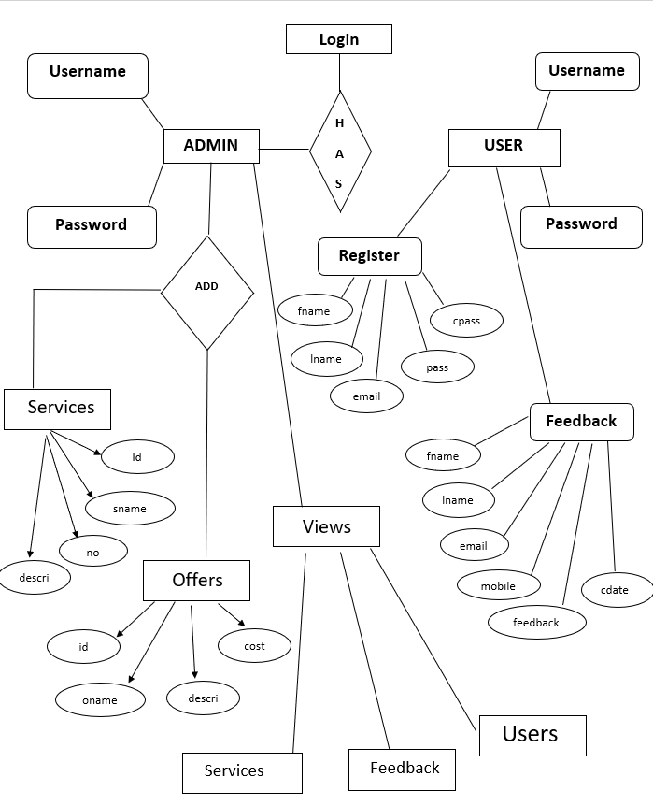**B. Entity Relationship Diagram (ERD):**

1. **Unified Modeling Language (UML) :**

Register

Login

**USER**

**ADMIN**

View Offers

View Services

Add Services

Delete Offers

Update Offers

Give Feedback

View Users

View Feedback

Add Offers

1. **System Design**
2. **Database Design**

FEEDBACK

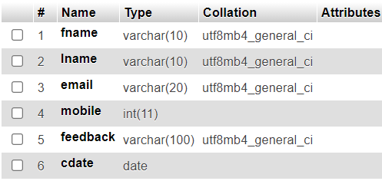

CUSTOMER REGISTRATION

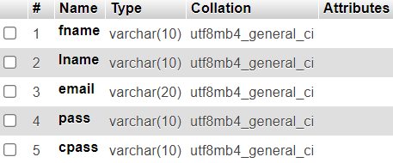

OFFER

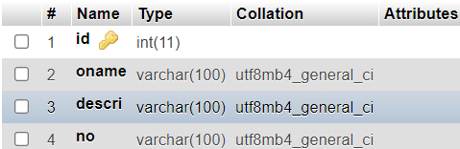

SERVICE

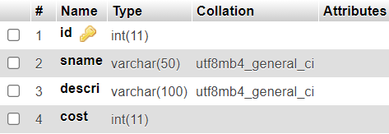

LOGIN

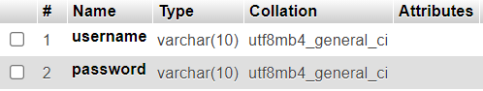

1. **Input Design** 
   * + - * ADMIN INPUT:

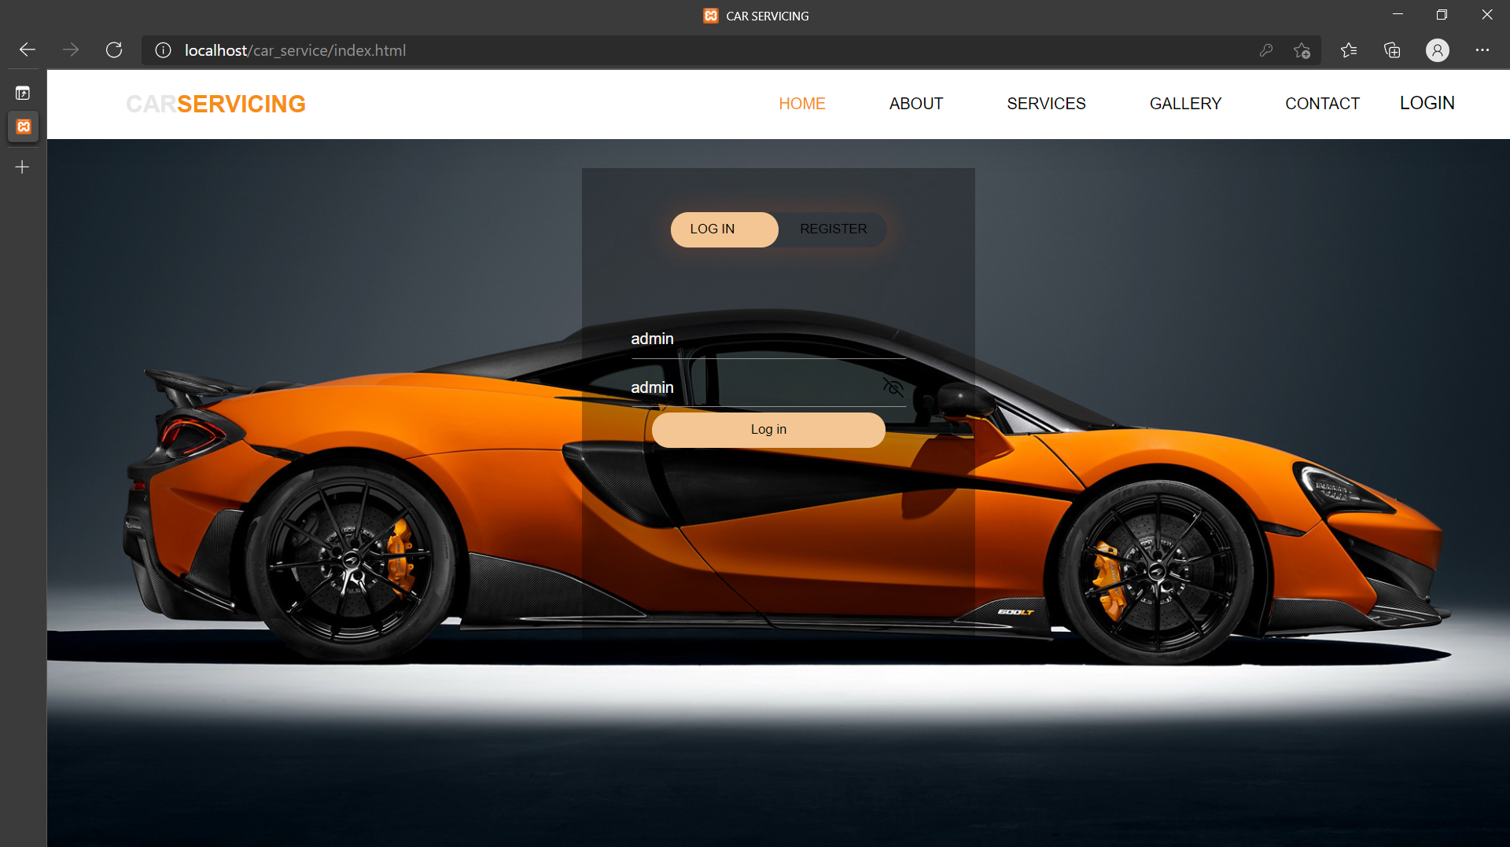

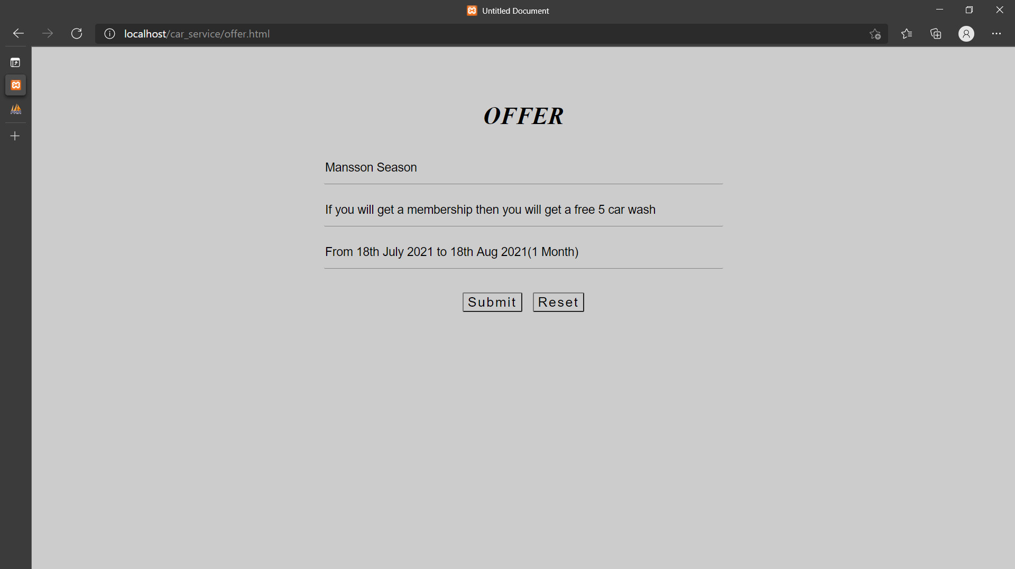

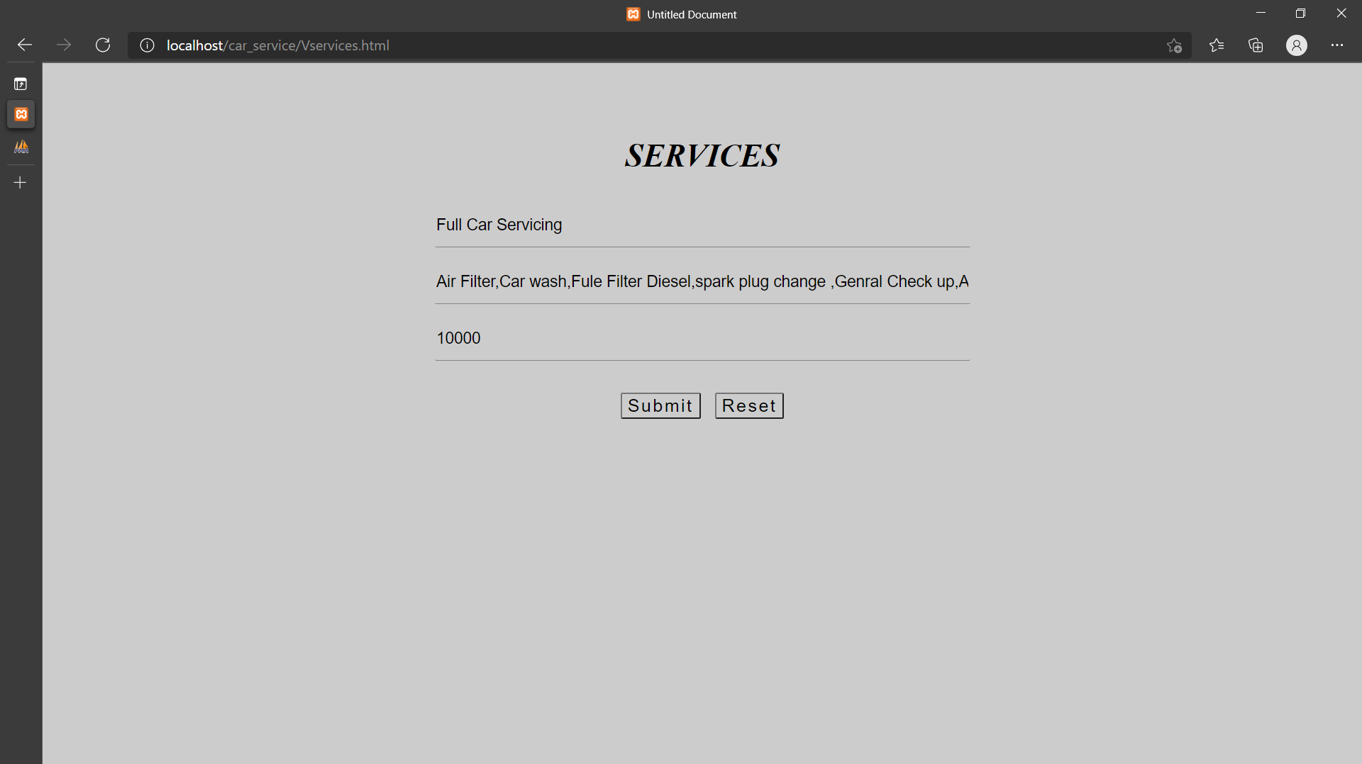

* + - * + USER INPUT:

REGISTRATION

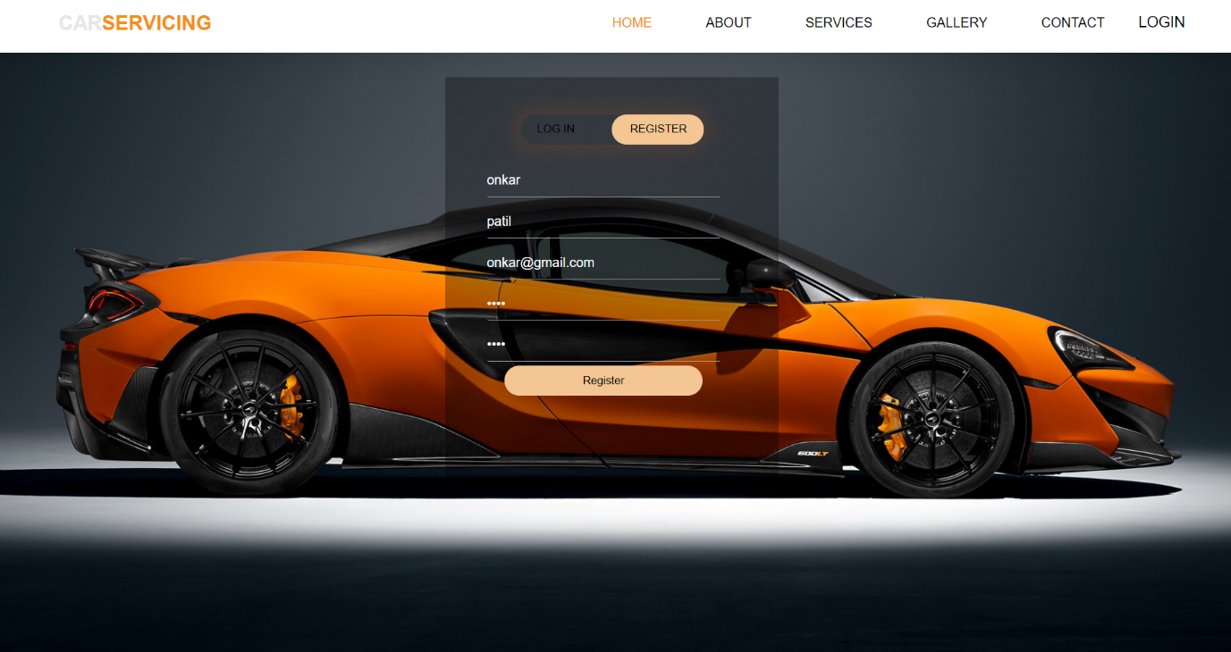

FEEDBACK

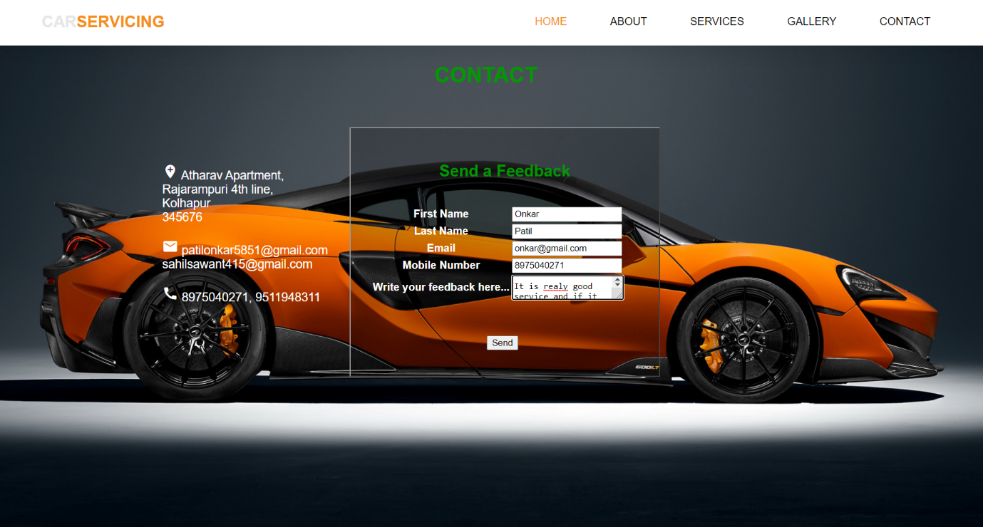

LOG IN

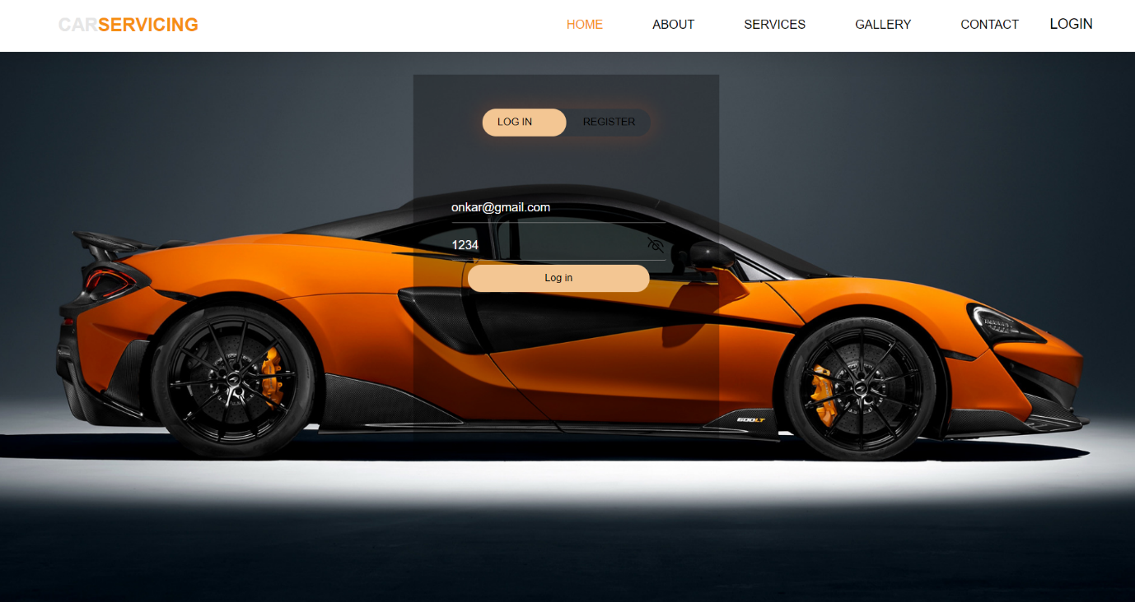

1. **Output Design**

ADMIN OUTPUT:

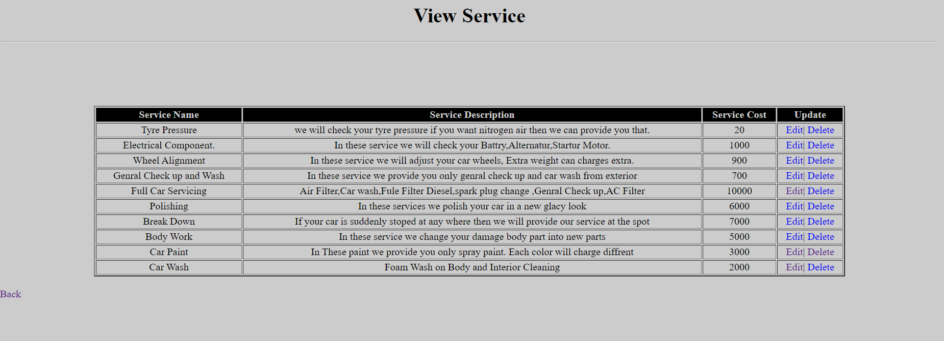

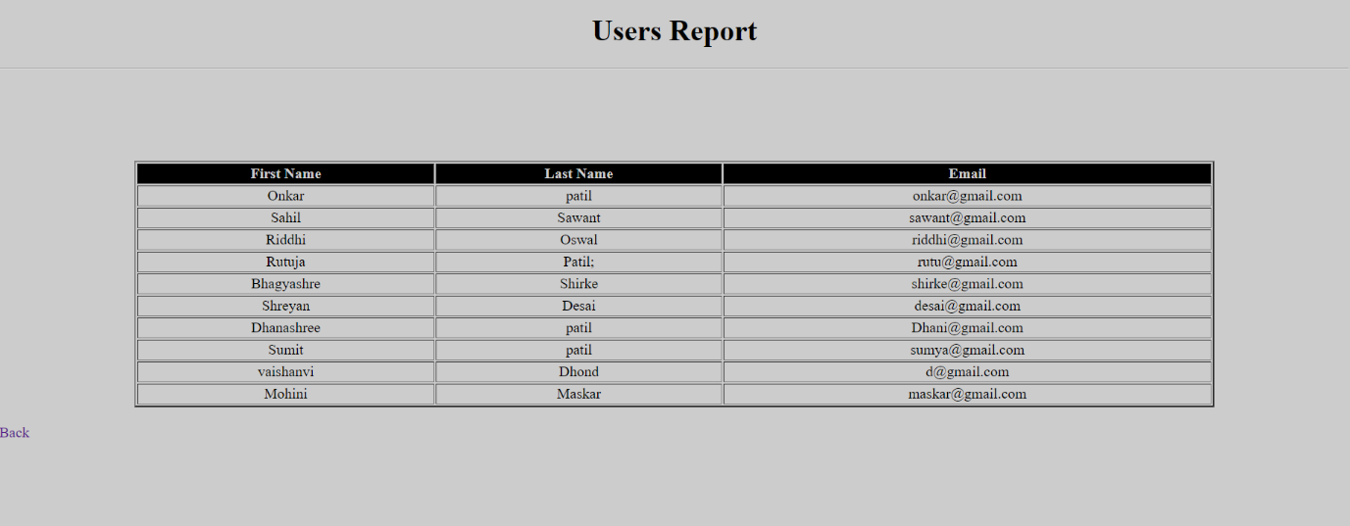

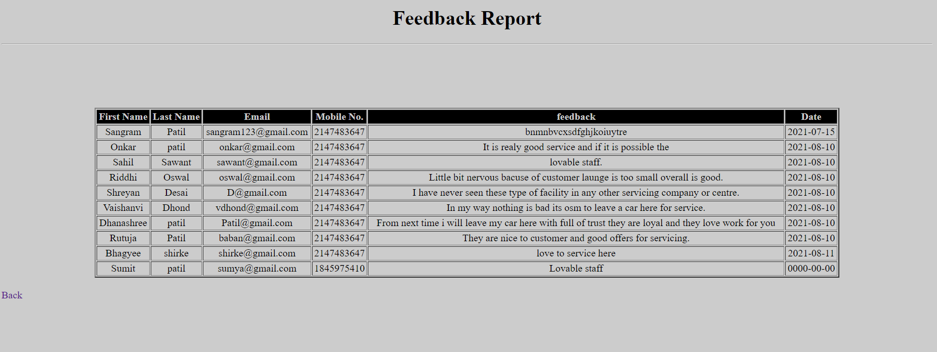

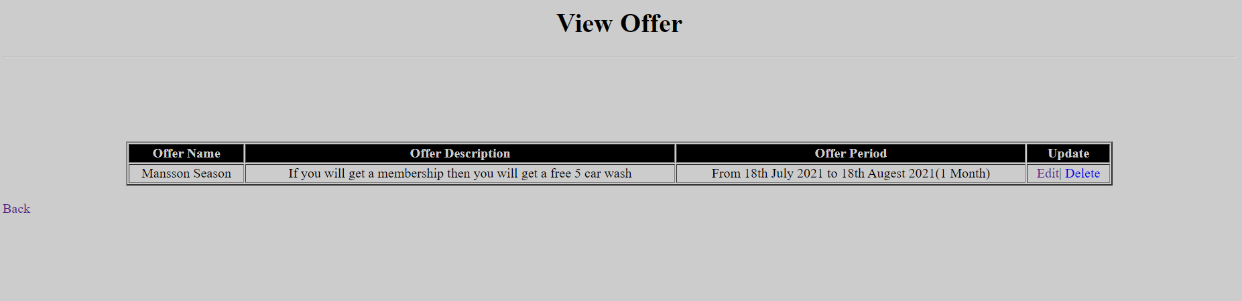

USER OUTPUT:

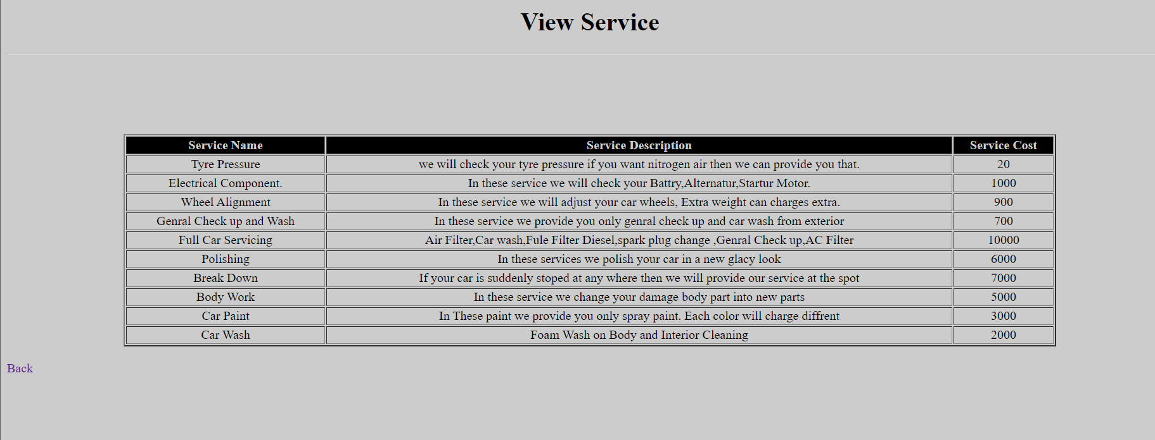

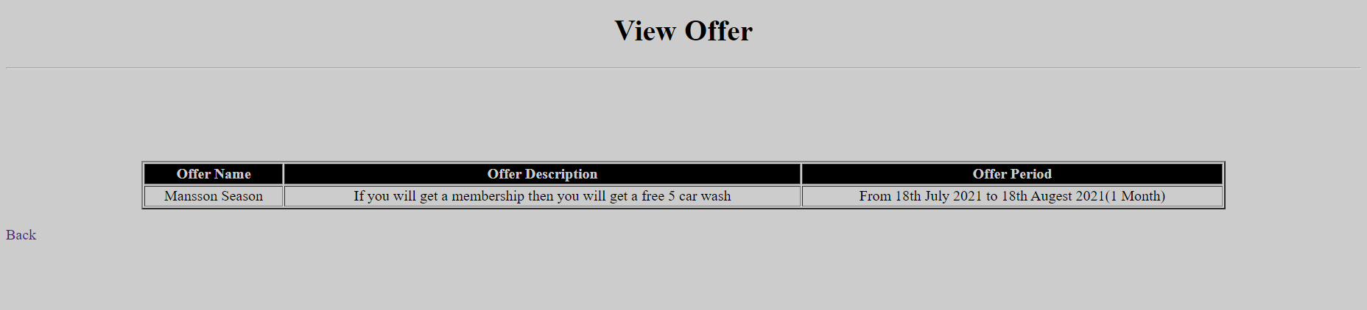

1. **CODE:**

* HOME Page:

<head>

<meta http-equiv="Content-Type" content="text/html; charset=iso-8859-1" />

<title>CAR SERVICING</title>

<link rel="stylesheet" type="text/css" href="css/style.css" />

<script language="javascript">

function valid()

{

var name1=document.getElementById("username").value;

var pass1=document.getElementById("password").value;

if(name1=="")

{

alert("Enter Your Username...");

document.getElementById("username").focus();

return false;

}

if(pass1=="")

{

alert("Enter Your Password...");

document.getElementById("password").focus();

return false;

}

return true;

}

</script>

<script language="javascript">

function valid1()

{

var fname1=document.getElementById("fname").value;

var lname1=document.getElementById("lname").value;

var email1=document.getElementById("email").value;

var pass1=document.getElementById("pass").value;

var cpass1=document.getElementById("cpass").value;

if(fname1=="")

{

alert("Enter Your First Name...");

document.getElementById("fname").focus();

return false;

}

if(lname1=="")

{

alert("Enter Your Last Name...");

document.getElementById("lname").focus();

return false;

}

if(email1=="")

{

alert("Enter Your Email...");

document.getElementById("email").focus();

return false;

}

if(pass1=="")

{

alert("Enter Your Password...");

document.getElementById("pass").focus();

return false;

}

if(cpass1=="")

{

alert("Enter Your Feedback...");

document.getElementById("cpass").focus();

return false;

}

return true;

}

</script>

</head>

<body>

<section class="landing">

<div class="nav_bar">

<h1><font color="#000033">Car</font><span>Servicing</span></h1>

<nav>

<ul>

<li><a href="index.html" class="active">Home</a></li>

<li><a href="about.html">About</a></li>

<li><a href="services.html">Services</a></li>

<li><a href="gallery.html">Gallery</a></li>

<li><a href="contact.html">Contact</a></li>

<li><button class="loginbtn" onclick="document.getElementById('login-form').style.display='block'" style="width:auto;">LOGIN</button></li>

</ul>

</nav>

</div>

<!--Login-->

<div id="login-form" class="login-page" >

<div class="form-box">

<div class="button-box">

<div id="btn"></div>

<button type="button" onclick="login()" class="toggle-btn">LOG IN</button>

<button type="button" onclick="register()" class="toggle-btn" style="float:right">REGISTER</button>

</div>

<form id="login" class="input-group-login" method="post" action="adcheck.php">

<input type="text" name="username" id="username" class="input-field" placeholder="Username" required />

<input type="password" name="password" id="password" class="input-field" placeholder="Enter Password" required />

<button type="submit" name="Login" value="Login" onclick="return valid();" class="submit-btn">Log in</button>

</form>

<!--Resiter-->

<form id="register" class="input-group-register" action="radd.php" method="post" name="form1">

<input type="text" class="input-field" name="fname" id="fname" placeholder="First Name" required />

<input type="text" class="input-field" name="lname" id="lname" placeholder="Last Name" required />

<input type="email" class="input-field" name="email" id="email" placeholder="Email Id" required />

<input type="password" class="input-field" name="pass" id="pass" placeholder="Enter Password" required />

<input type="password" class="input-field" name="cpass" id="cpass" placeholder="Confirm Password" required />

<button type="submit" value="Register" onclick="return valid1();" name="Register" class="submit-btn">Register</button>

</form>

</div>

</div>

</div>

<script>

var x=document.getElementById('login');

var y=document.getElementById('register');

var z=document.getElementById('btn');

function register()

{

x.style.left='-400px';

y.style.left='50px';

z.style.left='110px';

}

function login()

{

x.style.left='50px';

y.style.left='450px';

z.style.left='0px';

}

</script>

<script>

var modal = document.getElementById('login-form');

window.onclick = function(event)

{

if(event.target == modal)

{

modal.style.display = "none";

}

}

</script>

</body>

</html

* Contact Us Code :

<head>

<meta http-equiv="Content-Type" content="text/html; charset=iso-8859-1" />

<title>Contact</title>

<link href="https://fonts.googleapis.com/icon?family=Material+Icons" rel="stylesheet">

<link href="css/contact.css" type="text/css" rel="stylesheet" />

<script language="javascript">

function valid()

{

var fname1=document.getElementById("fname").value;

var lname1=document.getElementById("lname").value;

var email1=document.getElementById("email").value;

var mobile1=document.getElementById("mobile").value;

var feedback1=document.getElementById("feedback").value;

if(fname1=="")

{

alert("Enter Your First Name...");

document.getElementById("fname").focus();

return false;

}

if(lname1=="")

{

alert("Enter Your Last Name...");

document.getElementById("lname").focus();

return false;

}

if(email1=="")

{

alert("Enter Your Email...");

document.getElementById("email").focus();

return false;

}

if(mobile1=="")

{

alert("Enter Your Mobile No...");

document.getElementById("mobile").focus();

return false;

}

if(feedback1=="")

{

alert("Enter Your Feedback...");

document.getElementById("feedback").focus();

return false;

}

return true;

}

</script>

</head>

<body>

<section class="landing">

<div class="nav_bar">

<h1>Car<span>Servicing</span></h1>

<nav>

<ul>

<li><a href="index.html" class="active">Home</a></li>

<li><a href="about.html">About</a></li>

<li><a href="services.html">Services</a></li>

<li><a href="gallery.html">Gallery</a></li>

<li><a href="contact.html">Contact</a></li>

</ul>

</nav>

</div>

<h2 class="h2" >CONTACT</h2>

<div class="one">

<ul >

<li>

<span><i class="material-icons">add_location</i></span>

<span>Atharav apartment,<br />

rajarampuri 4th line,<br />

Kolhapur<br />

345676</span>

</li><br />

<li>

<span><i class="material-icons">email</i></span>

<span>atharav123@gmail.com</span>

</li><br />

<li>

<span><i class="material-icons">call</i></span>

<span>8753547656</span>

</li>

</ul>

</div>

<div class="two">

<h2>Send a Feedback</h2>

<form action="add.php" method="post" name="form1">

<table>

<tr>

<th> <label>First Name</label></th>

<td><input type="text" name="fname" id="fname" required /></td>

</tr>

<tr><br />

<th> <label>Last Name</label></th>

<td> <input type="text" name="lname" id="lname" required /></td>

</tr>

<tr>

<th> <label>Email </label></th>

<td> <input type="email" name="email" id="email" required /></td>

</tr>

<tr>

<th><label>Mobile Number</label></th>

<td><input type="text" name="mobile" id="mobile" required /></td>

</tr>

<tr>

<th><label>Write your feedback here...</label></th>

<td><textarea name="feedback" id="feedback" required ></textarea></td>

</tr>

<tr>

<td colspan="2"><input type="submit" value="Send" name="Send" onclick="return valid();" class="btn" /></td>

</tr>

</table>

</form>

</div>

</body>

</html>

* Add Services Code :

<head>

<meta http-equiv="Content-Type" content="text/html; charset=iso-8859-1" />

<title>Services</title>

<meta name="viewport" content="width=device-width, initial-scale=1" />

<link rel="stylesheet" href="https://stackpath.bootstrapcdn.com/font-awesome/4.7.0/css/font-awesome.min.css" integrity="sha384-wvfXpqpZZVQGK6TAh5PVlGOfQNHSoD2xbE+QkPxCAFlNEevoEH3Sl0sibVcOQVnN" crossorigin="anonymous">

<link href="css/services.css" rel="stylesheet" type="text/css" />

</head>

<body>

<section class="landing">

<div class="nav_bar">

<h1>Car<span>Servicing</span></h1>

<nav>

<ul>

<li><a href="index.html" class="active">Home</a></li>

<li><a href="about.html">About</a></li>

<li><a href="service.html">Services</a></li>

<li><a href="gallery.html">Gallery</a></li>

<li><a href="contact.html">Contact</a></li>

</ul>

</nav>

</div>

<div class="services-section">

<div class="inner-width">

<h1 class="section-title">Our Services</h1>

<div class="border"></div>

<div class="services-container">

<div class="service-box">

<div class="service-icon">

<img src="img/m.jpg" height="70px" width="70px" />

</div>

<div class="service-title">Preventive Maintenance Service</div>

<div class="service-desc">

To keep your car fine and running, we provide a regular check-up which will avoid your car from facing bigger problems. Also, cheering up your car with routine services will lead to better performance in return.

</div>

</div>

<div class="service-box">

<div class="service-icon">

<img src="img/running.jpg" height="70px" width="70px" />

</div>

<div class="service-title">Running Repairs</div>

<div class="service-desc">

It matters to us that your car takes you to your destinations safely as well as smoothly and we are here to take care of it for you.

</div>

</div>

<div class="service-box">

<div class="service-icon">

<img src="img/w.jpg" height="70px" width="70px" />

</div>

<div class="service-title">Warranty Beyond Warranty</div>

<div class="service-desc">

Coverage of all kinds of Electrical & Mechanical failures.

</div>

</div>

<div class="service-box">

<div class="service-icon">

<img src="img/wheel.jpg" height="70px" width="70px" />

</div>

<div class="service-title">Wheel Care</div>

<div class="service-desc">

The wheels of your car need regular attention and care. Wheels get damaged due to bad roads and pot holes leading to misalignment.

</div>

</div>

<div class="service-box">

<div class="service-icon">

<img src="img/Accessories.jpg" height="70px" width="70px" />

</div>

<div class="service-title">Accessories</div>

<div class="service-desc">

Car accessories like steering wheel cover and floor mats which are available in different styles and designs.

</div>

</div>

<div class="service-box">

<div class="service-icon">

<img src="img/body.jpg" height="70px" width="70px" />

</div>

<div class="service-title">Car Body Repairs</div>

<div class="service-desc">

Body repair helps to improve the appearance and resale value of the car.If you wish to get rid of those scratches and dents on your car.

</div>

</div>

</div>

</div>

</div>

</body>

</html>

* View Feedback Code:

<!DOCTYPE html PUBLIC "-//W3C//DTD XHTML 1.0 Transitional//EN" "http://www.w3.org/TR/xhtml1/DTD/xhtml1-transitional.dtd">

<html xmlns="http://www.w3.org/1999/xhtml">

<head>

<meta http-equiv="Content-Type" content="text/html; charset=iso-8859-1" />

<title>Untitled Document</title>

<style>

td{

text-align:center;

color:#000000;

}

table{

margin-top:100px;

}

a{

text-decoration:none;

}

</style>

</head>

<body>

<?php

//including the database connection file

include_once("connection.php");

//fetching data in descending order (lastest entery first)

//$result = mysql_query(SELECT * FROM users ORDER BY id DESC");

//mysql_query is deprecated

$result = mysqli_query($conn, "SELECT * FROM feedback ");//using mysqli_query instead

?>

<html>

<head>

<title>Home Page</title>

</head>

<body bgcolor="#CCCCCC">

<h1><center>Feedback Report</center></h1><hr />

<table width="80%" border="2" align="center">

<tr bgcolor="#000000">

<td style="color:#CCCCCC; font-weight:bold">First Name</td>

<td style="color:#CCCCCC; font-weight:bold" >Last Name</td>

<td style="color:#CCCCCC; font-weight:bold">Email</td>

<td style="color:#CCCCCC; font-weight:bold">Mobile No.</td>

<td style="color:#CCCCCC; font-weight:bold">feedback</td>

<td style="color:#CCCCCC; font-weight:bold">Date</td>

</tr>

<?php

while($res=mysqli_fetch_array($result)) {

echo"<tr>";

echo"<td>".$res['fname']."</td>";

echo"<td>".$res['lname']."</td>";

echo"<td>".$res['email']."</td>";

echo"<td>".$res['mobile']."</td>";

echo"<td>".$res['feedback']."</td>";

echo"<td>".$res['cdate']."</td>";

}

?>

</table>

<br />

<a href="Views.html">Back</a>

</body>

</html>

1. **System Requirements:**

**Hardware Requirements:**

Processor : 1GHZ

RAM : 512MB

**Software Requirements:**

Front end : PHP, HTML, CSS, JAVA SCRIPT.

Back end : MySQL

Server : XAMPP Server.

1. **Front end and Back end :**

**Front End :** HTML, CSS , Java Script, PHP.

**Back End :** My SQL ,XAMPP.

**HTML and CSS :**

**Hypertext Markup Language** (**HTML**) is the standard markup language for documents designed to be displayed in a web browser. It can be assisted by technologies such as**Cascading Style Sheets** (CSS) and scripting languages such as JavaScript.

CSS is the language for describing the presentation of Web pages, including colors, layout, and fonts. It allows one to adapt the presentation to different types of devices, such as large screens, small screens, or printers. CSS is independent of HTML and can be used with any XML-based markup language.

Web browsers receive HTML documents from a web server or from local storage and render the documents into multimedia web pages. HTML describes the structure of a web page semantically and originally included cues for the appearance of the document.  
  
HTML elements are the building blocks of HTML pages. With HTML constructs, images and other objects such as interactive forms may be embedded into the rendered page. HTML provides a means to create structured documents by denoting structural semantics for text such as headings, paragraphs, lists, links, quotes and other items.

**JavaScript:**

JavaScript, often abbreviated as JS, is a programming language that conforms to the ECMAScript specification. JavaScript is high-level, often just-in-time compiled, and multi-paradigm. It has curly-bracket syntax, dynamic typing, prototype-based object-orientation, and first-class functions.

**XAMPP Server:**

XAMPP is a free and open-source cross-platform web server solution stack package developed by Apache Friends, consisting mainly of the Apache HTTP Server, MariaDB database, and interpreters for scripts written in the PHP and Perl programming languages. Since most actual web server deployments use the same components as XAMPP, it makes transitioning from a local test server to a live server possible.  
XAMPP's ease of deployment means a WAMP or LAMP stack can be installed quickly and simply on an operating system by a developer, with the advantage that common add-in applications such as WordPress and Joomla! can also be installed with similar ease using Bitnami. Though it is a heavy app for most of the operating systems even when owing to its less size it takes a load on the processor speed.

**My SQL:**

Microsoft SQL Server is a relational database management system developed by Microsoft. As a database server, it is a software product with the primary function of storing and retrieving data as requested by other software applications—which may run either on the same computer or on another computer across a network (including the Internet). Microsoft markets at least a dozen different editions of Microsoft SQL Server, aimed at different audiences and for workloads ranging from small single-machine applications to large Internet-facing applications with many concurrent users.

1. **Output**

**Screen and Report (with valid data)**

ADMIN OUTPUT:









USER OUTPUT:





1. **Project Conclusion & Limitation**

1. **Conclusion:**

* It gives the security of the data, by providing facility during loading the project and formatting the database.
* It gives validation of data.
* System gives fast and accurate result it reduces the work as well as labor cost and increases accuracy and fast execution of work.

1. **Limitations of Existing System:**
2. In manual system it is difficult to access to required information quickly.
3. It is time consuming.
4. It is not user friendly.
5. **Suggestions:**

FUTURE ENHANCEMENTS:  
 This application avoids the manual work and the problems concern with it. It is an easy way to obtain the information regarding the various products information that are present in the Super markets.  
  
Well I and my team members have worked hard in order to present an improved website better than the existing one’s regarding the information about the various activities. Still ,we found out that the project can be done in a better way. Primarily, when we request information about a particular product it just shows the company, product id, product name and no. of quantities available. So, after getting the information we can get access to the product company website just by a click on the product name .  
  
The next enhancement that we can add the searching option. We can directly search to the particular product company from this site .These are the two enhancements that we could think of at present.

1. **BIBLIOGRAPHY :**
2. The Joy of PHP Programming: A Beginner's Guide – by Alan Forbes.  
   2. Learning PHP, MySQL, JavaScript, and CSS: A Step-by-Step Guide to Creating Dynamic Websites – by Robin Nixon.  
   3. MySQL” by Paul DuBois  
   4. “HTML and CSS: Design and Build Websites” by Jon Ducket  
   5. Learning Web Design: A beginner’s Guide To HTML, CSS, Javascript, and Web Graphics.   
     
   WEBSITES:  
   [www.google.com](http://www.google.com/)

[www.wikipedia.com](http://www.wikipedia.com)